
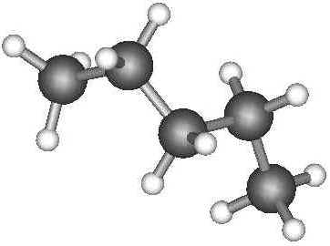
Topic 5: Fuels

At the end of this topic you can check your understanding of these key points Text in blue is required for credit level

1 A fuel is a chemical which burns giving out energy

2 A combustion reaction is one in which a compound usually a hydrocarbon containing the elements C, H, O burns in a plentiful supply of oxygen to produce CO_{2(g)} and H₂O_{(l)}. Coal and many hydrocarbons contain the impurity Sulphur S. These fuels combust to produce CO_{2(g)} , H₂O_{(l)} and an additional poisonous gas called sulphur dioxide SO_{2(g)} This builds up in the atmosphere and is washed onto the land by rain causing acid rain pollution. The removal of SO_{2(g)} from coal and hydrocarbons reduces air pollution

3 The test for oxygen gas is that it re-lights a glowing splint

4 The main components of air are oxygen and nitrogen in proportion of 1:4 or Nitrogen 78% Oxygen 21% other gases like CO₂ less than 1%

5 Cars burn hydrocarbons by combining the hydrocarbon fuel mixture with air. The sparking of air (containing nitrogen and oxygen) inside a car’s engine produces harmful nitrogen dioxide (NO₂) another gas that causes acid rain

6 Complete combustion needs a plentiful supply of oxygen and can be written as this equation:

C _{(s)} + O₂ _{(g)} CO _{2(g)}

Incomplete combustion means there is not enough oxygen to burn all the carbon. Gas boilers have to be checked regularly as a sooty yellow flame is a sign of incomplete combustion. Incomplete combustion of carbon gives a different equation.
C _{(s)} + ½O₂ _{(g)} CO_{(g)}



CHECKPOINT

Remember Carbon monoxide CO_{(g)} is the toxic (poisonous) gas produced

7 An exothermic reaction is one in which energy is released (remember exit means energy out)

8 Fossil fuels are non renewable sources of energy millions of years old.
We are burning them faster than they can be made. Fossil fuels like coal, oil and natural gas cause pollution e.g. acid rain, oil pollution and car exhaust emissions.

9 Hydrogen is a gas that can be tested with a lit splint. It burns with a squeaky pop to give non-polluting water and energy. Hydrogen reacts with oxygen. This is an exothermic reaction that gives out energy. Hydrogen fuel is a renewable source of energy as it can be obtained from water which will never run out.

10 Crude oil is a complex mixture of mainly hydrocarbon compound molecules. Remember a mixture consists of two or more elements or compounds which are not chemically combined. This is why the crude oil mixture can be separated into various more useful parts called fractions A fraction. contains similar sized molecules with about the same number of carbon atoms and this gives each fraction distinctive physical properties. Look at the diagram of the fractionation column to find out more about the uses of the fractions obtained from crude oil. The chemical property’s of each fraction is unchanged by this process of separation.
The process of separation which produces fractions by distillation is called FRACTIONAL DISTILLATION
Remember crude oil can be separated by physical methods, in this case by fractional distillation, because they have different boiling and condensation points. To do this :
- The crude oil is heated to boil and vaporise it ( a physical change)
- The most volatile fraction, i.e. the molecules with the lowest boiling points, boil or evaporate off first and go to the top of the column.
- The rest separate out according to their boiling/condensation point so that the highest boiling fraction, i.e. the less volatile molecules with higher boiling points, tend to condense more easily lower down the column.
The bigger the molecule, the greater the intermolecular attractive forces between the molecules, so the higher the boiling or condensation Note: Covalent chemical bonds like C-C or C-H are not broken in the process, only the intermolecular force of attraction is weakened to allow the initial evaporation or boiling.

CHECKPOINT

Remember hydrocarbon molecules are made of a chemical combination of only carbon and hydrogen atoms.
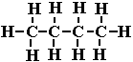

Equations for the complete combustion of a hydrocarbon

When a hydrocarbon molecule (reactant) burns in a good supply air/oxygen there are only two products of the reaction. The carbon atoms are oxidised on combining with oxygen to form carbon dioxide molecules, and the hydrogen atoms are oxidised to form water molecules ('hydrogen oxide'). Remember if the hydrocarbon being burned contains sulphur as an impurity then SO_{2(g)} will also be one of the products on the right side.
Remember to write the right equation
General word equation: hydrocarbon + oxygen ==> carbon dioxide + water
Specific Word equations e.g. methane + oxygen ==> carbon dioxide + water
and the corresponding symbol equation is
CH_{4(g)} + 2O_{2(g)} ==> CO_{2(g)} + 2H₂O_{(l)}
Note that one CO₂ for every C, and one H₂O for every two H's in the hydrocarbon molecule.
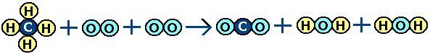
In terms of displayed formula the equation should be written with every individual atom shown and how it is bonded ('connected') with other atoms in the molecule. All the lines represent the covalent bonds between the atoms in the molecules.
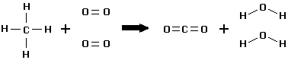
.
From an examination of the products of the combustion of a hydrocarbon it can be seen that the products contain C and H atoms that originate from the hydrocarbon fuel but O₂ comes from the air. If the hydrocarbon also produces SO_{2 (g)} then the original hydrocarbon also contained sulphur S.

THE FRACTIONAL DISTILLATIONOF CRUDE OIL | names of fractions | C atoms in the molecule | boiling range inºC | USES of the fraction - mainly depends on its physical properties - see below this table
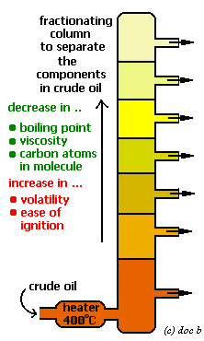 | Fuel Gas, LPG, Refinery Gas | 1 to 4 | -160 to 20ºC | methane gas fuel, C₃₋₄ easily liquefied, portable energy source bottled gas for cooking (butane), higher pressure cylinders (propane) combustion-burning reaction details
 | Gasoline, Petrol | 5 to 11 | 20 to 60ºC | easily vaporised, highly flammable, easily ignited, car fuel
 | Naphtha | 7 to 13 | 60 to 180ºC | no good as a fuel, but valuable source of organic molecules to make other things,cracked to make more petrol and alkenes
 | Paraffin, Kerosene | 10 to 16 | 120 to 240ºC | less flammable than petrol, domestic heater fuel, jet fuel
 | Diesel oil, Gas oil | 15 to 25 | 220 to 250ºC | car and larger vehicle fuel
 | Fuel oil, lubricating oils and Waxes | 20 to 70 | 250 to 350ºC | not so easily evaporated, not as flammable, safe to store for central heating oil, quite viscous (sticky) and can also be used for lubricating oils, clear waxes and polishes
 | Bitumen | over 70 | over 350ºC | forms a thick, black, tough and resistant adhesive on cooling, used as waterproofing material and to sticks rock chips on roofs or road surfaces

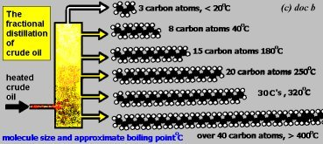

CREDIT LEVEL IN BLUE

More on relating the physical properties of the fractions to their uses and dangers
As you go down towards the bottom of the tower the molecule gets ...
- ... bigger as the carbon atom number in the molecule increases.
- ... more viscous as the intermolecular attractive forces between molecules increases, these forces always increase the bigger the molecule in a series of molecules of similar structure.
- Note that intermolecular forces are weak electrical attractive forces, often described as Van der Waals forces that act between molecules to pull them closer together
- ... higher melting point as more kinetic energy is needed to overcome the intermolecular attractive forces holding the molecules together.
- ... higher boiling point as more particle kinetic energy is needed to overcome the increasing intermolecular forces between the liquid molecules.
  - Trends 3. and 4. explain why e.g. methane is a gas (CH₄), petrol is liquid (about C₅H₁₂ to C₇H₁₆) and candlewax (over C₂₁H₄₄) is solid
- ... less flammable as they become less volatile, again due to increasing intermolecular forces.
  - This raises health and safety issues about handling, distributing and storing flammable hydrocarbons. The smallest molecules (natural gas to petrol) are the most volatile and therefore the most easily ignited. Any naked flame or spark could set off a fire and explosion and even
- The refinery gas fractions, can be stored under pressure, and because the gas readily flows, it can be conveniently pumped to burner systems, but it is easily ignited and explosive.
- Vehicle fuels like petrol must be liquid for compact and convenient storage but they must be easily vapourised to mix with air in the engine prior to ignition. The ease of vaporisation does however make them flammable!
- Paraffin and kerosine are less flammable and safer, but not as easily ignited.
- Fuel oil is not too viscous to pump to a central heating burner for domestic use. It is not very volatile and so not as flammable and dangerous to use as petrol or diesel etc.
- Lubricating oil must be quite viscous to stick onto surfaces. Smaller molecules might be more runny but they would evaporate away! It is also water repellent and helps reduce corrosion on moving machine parts.
- Candle wax is very convenient as a solid for humble lamps (especially in power cuts!), but via a wick, the heat from the flame is sufficient to vaporise the hydrocarbons to burn them.
- Bitumen is a water repellent solid at room temperature but is readily melted (sometimes too easily in hot weather). Used as base for a road chipping top surface or sometimes directly. It is also used to waterproof roofing felt.

Hydrocarbons burn completely to produce only carbon dioxide and
water
Coal combustion
- The fuel coal consists mainly of carbon, which, if burned/ignited in excess air, combusts to form carbon dioxide.
  - carbon + oxygen ==> carbon dioxide
  - C_{(s)} + O_{2(g)} ==> CO_{2(g)}
  - This is what you expect to happen in an open domestic coal fire.
- If not enough air/oxygen is available, coal will only 'half' burn to form the deadly odourless, colourless and toxic gas carbon monoxide.
  - 2C_{(s)} + O_{2(g)} ==> 2CO_{(g)}
  - This can happen if organic material, coal or peat is smouldering underground and is obviously a dangerous situation.
  - If it was formed in a domestic coal fire it will quite happily burn with a pale blue flame to form the 'safe' combustion gas carbon dioxide.
  - 2CO_{(s)} + O_{2(g)} ==> 2CO_{2(g)}

- This experiment shows how to detect the products of hydrocarbon combustion e.g. burning candle wax.

- When hydrocarbons are burned in air a fast exothermic reaction occurs releasing heat and forming carbon dioxide and water.
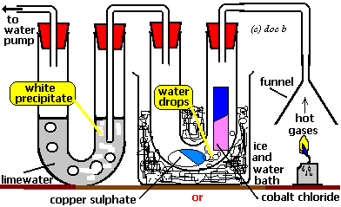

Limewater turns milky white when bubbles of CO₂ pass through it

We can check this product is water by testing its boiling point is 100 °C and its freezing point is 0°C

Blue Copper sulphate forms in the presence of water

Cobalt chloride turns pink in the presence of water
We can check this product is CO₂ by testing with limewater

Checkpoint
- The carbon dioxide is chemically detected with limewater - with which it forms a white precipitate (milky appearance) of calcium carbonate.
- The water is chemically detected either by (i) anhydrous white copper sulphate turning blue OR (ii) dried blue cobalt chloride paper turning pink.
- A physical test for water is to measure its boiling point (should be 100ºC).

Air pollution from the burning of petrol and diesel which are both hydrocarbons can be reduced by fitting special types of exhaust system to cars. These are called catalytic convertors



