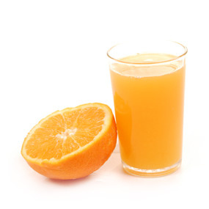
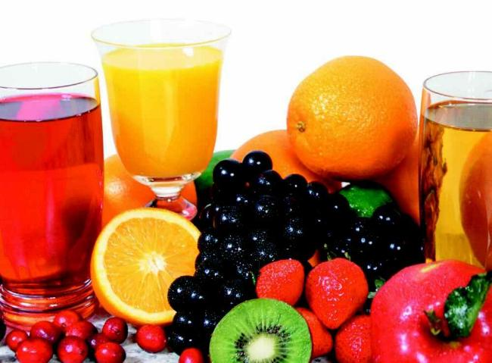
TESTING
Fruit
Juices
For
Acids

By Michael Williamson

INTRODUCTION

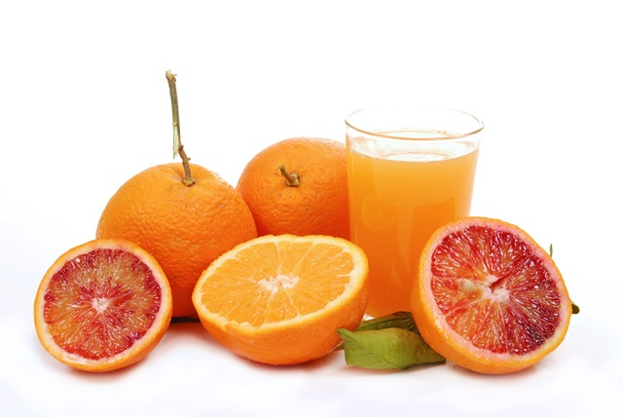
Fruit juices come in a variety of flavours such as apple and orange. Fruit juices contain acids to give it a nice tangy taste such as Dr Pepper and coca cola have this tangy taste. To much acid can rot your teeth so too much coca cola will rot your teeth. Not all acids are but like orange juice, it contains a acid called citric acid which is high in vitamin C. Vitamin C is also known as ascorbic acid, this is a vital nutrient required by the human body for growth and repair of tissues. When sailors went out to sea they would get a disease called scurvy which is caused by lack of vitamin C, so that is why they would take oranges and lemons onboard to cure scurvy. There are a lot of brands such as Vitafit and Robinsons, you can try to make your own it’s real easy. Orange juice is a popular beverage as it is made from oranges. When you squeeze a lemon and if you drink the liquid it will be very sour but that is because it is concentrated and needs added water. Freshly squeezed orange juice is not heated also known as pasteurized. Filtered orange juice is pasteurized and is evaporated under a vacuum. A small fraction of fresh orange juice is canned. Canned orange juice does retain Vitamin C much better than bottled juice. However, the canned product loses flavor when stored at room temperature for over 12 weeks. Orange juice usually varies between shades of orange and yellow, though some ruby red or blood orange varieties are a reddish-orange or even pinkish. This is due to different pigmentation in ruby red oranges.
METHOD

For this test you will need
5 x Fruit Juices Samples
Dimple Tray
Dropping Pipette
Universal Indicator (pH) Paper

METHOD

First add a few drops of one of the fruit juices to a dimple tray.
Second Use a piece of pH paper to test the pH of fruit juice
Third take a note of the pH in the results table
Fourth Re-test the pH of the juice twice more and note the pH values in the results table
Fifth Repeat steps 1-4 for the other 4 juices

RESULTS

pH value
juice type | Test 1 | Test 2 | Test 3 | Average
Orange | pH4 | pH3 | pH4 | pH3.7
Apple | pH3 | pH2 | pH2 | pH2
Cranberry | pH3 | pH3 | pH3 | pH3
Pineapple | pH4 | pH4 | pH4 | pH4

pH colour
Juice type | Test 1 | Test 2 | Test 3 | Average
Orange | Orange | Orange | Orange | Dark Orange
Cranberry | Orange | Orange | Orange | Orange
Apple | Orange | Red | Red | Red
Pineapple | Orange | Orange | Orange | Dark Orange
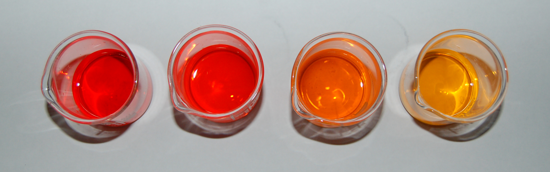

Conclusion

When I was doing the fruit juice experiment I found out a lot of things. For one I never knew that fruit juice contained acid.
I did not get the results I expected as some of the different flavours of juice contain a higher and lower pH scale.
Next time I will need to improve my experiment by being more careful and not spilling any of the indicators.
I learned a lesson when I was doing this experiment, that when I’m taking the sample to remember to shake it not stir it.
The person that sat beside me had a brighter colour and mine was quite red dark so I was not sure what pH to put down.
When we used the pH paper I had different colour from the universal indicator (solution) so I would rather use the pH paper as I think it would be more accurate.

Evaluation

Advantages of the universal indicator (solution), one advantage of the solution are that you can put as much of the solution in the juice in the experiment. A disadvantage is if you put in too much it will turn darker but if you put in too little that it will be a light colour.
Advantages for the universal indicator (pH paper) is that you don’t waste a lot of the universal indicator (solution). Another advantage is that you get a little tiny chart with it so you can take it anywhere and test it on anything (solution wise). A disadvantage is that sometimes the chart isn’t very accurate.

